print("=" * 60)
print(" MCP NEURON: LOGIC GATES")
print(" Program by: Manjil Simkhada")
print(" Roll No: 19")
print("=" * 60)

# --------------------------------------------------
# MCP NEURON FUNCTION
# --------------------------------------------------

def mcp_neuron(inputs, weights, T):
yin = 0

for x, w in zip(inputs, weights):
yin += x * w

if yin >= T:
return 1
else:
return 0

# --------------------------------------------------
# AND GATE
# --------------------------------------------------

def AND(x1, x2):
return mcp_neuron([x1, x2], [1, 1], 2)

# --------------------------------------------------
# OR GATE
# --------------------------------------------------

def OR(x1, x2):
return mcp_neuron([x1, x2], [1, 1], 1)

# --------------------------------------------------
# NOT GATE
# --------------------------------------------------

def NOT(x):
return mcp_neuron([x], [-1], 0)

# --------------------------------------------------
# NAND GATE
# --------------------------------------------------

def NAND(x1, x2):
return mcp_neuron([x1, x2], [-1, -1], -1)

# --------------------------------------------------
# NOR GATE
# --------------------------------------------------

def NOR(x1, x2):
return mcp_neuron([x1, x2], [-1, -1], 0)

# --------------------------------------------------
# XOR GATE
# XOR = (A OR B) AND NOT(A AND B)
# --------------------------------------------------

def XOR(x1, x2):

# First neuron: OR
or_output = OR(x1, x2)

# Second neuron: AND
and_output = AND(x1, x2)

# Third neuron: NOT of AND
not_and = NOT(and_output)

# Final neuron: AND
xor_output = AND(or_output, not_and)

return xor_output

# --------------------------------------------------
# DISPLAY RESULTS
# --------------------------------------------------

inputs = [(0, 0), (0, 1), (1, 0), (1, 1)]

print("\nAND GATE")
print("x1 x2 | y")
print("----------------")
for x1, x2 in inputs:
print(f"{x1} {x2} | {AND(x1, x2)}")

print("\nOR GATE")
print("x1 x2 | y")
print("----------------")
for x1, x2 in inputs:
print(f"{x1} {x2} | {OR(x1, x2)}")

print("\nNOT GATE")
print("x | y")
print("-----------")
for x in [0, 1]:
print(f"{x} | {NOT(x)}")

print("\nNAND GATE")
print("x1 x2 | y")
print("----------------")
for x1, x2 in inputs:
print(f"{x1} {x2} | {NAND(x1, x2)}")

print("\nNOR GATE")
print("x1 x2 | y")
print("----------------")
for x1, x2 in inputs:
print(f"{x1} {x2} | {NOR(x1, x2)}")

print("\nXOR GATE")
print("x1 x2 | y")
print("----------------")
for x1, x2 in inputs:
print(f"{x1} {x2} | {XOR(x1, x2)}")

print("\n" + "=" * 60)
print(" ALL LOGIC GATES IMPLEMENTED SUCCESSFULLY!")
print("=" * 60)

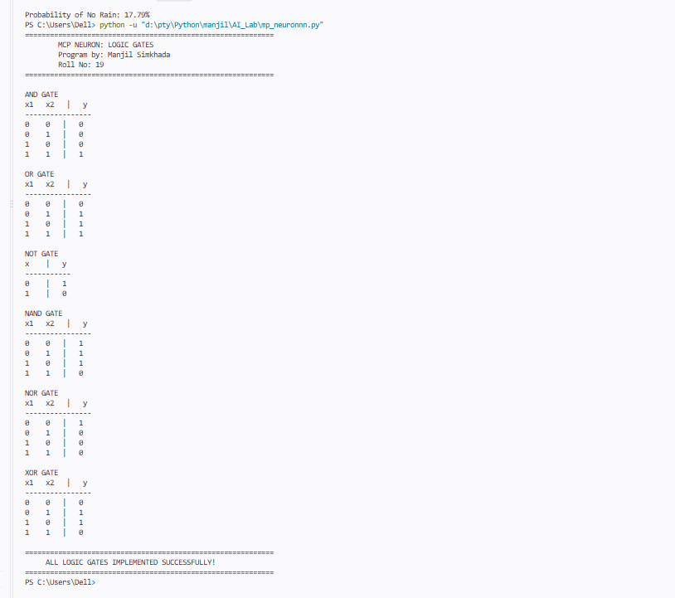

Conclusion
The MCP neuron was successfully implemented using Python to perform basic logical operations. AND, OR, NOT, NAND, NOR, and XOR gates were tested with all possible input combinations, and their outputs matched the expected truth tables. XOR was implemented using multiple MCP neurons because a single MCP neuron cannot represent the XOR function.

